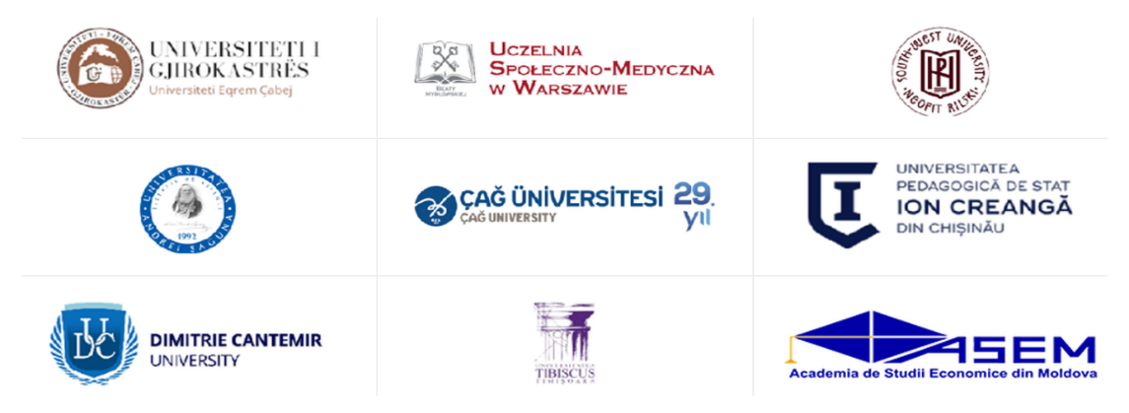

2nd Edition of International Conference
ARTIFICIAL INTELLIGENCE – INNOVATION IN EDUCATION IN A WORLD OF CONSTANT CHANGE
23–24 November 2026 | Târgu Mureș, Romania
Hybrid Conference

SUBMISSION GUIDELINES

SCIENTIFIC SECTIONS
Authors are requested to indicate the scientific section that best matches the topic of their submission.

- Dental medicine
- Economic Sciences
- Educational Sciences
- Geography
- Law
- Project Quality Management
- Psychology

IMPORTANT DATES

Activity | Deadline / Date
Abstract submission deadline | 23 October 2026
Conference dates | 23–24 November 2026
Full paper submission deadline (6–10 pages) | 1 December 2026

PUBLICATION

- Conference Abstract Book
All accepted abstracts will be included in a peer-reviewed Conference Abstract Book, to be published by a Romanian academic publishing house and assigned an ISBN.

- International Conference Proceedings
Following the conference, selected full-length papers that successfully pass the peer-review and editorial selection process will be considered for publication in an international conference proceedings volume with ISBN/ISSN and DOI. The proceedings are intended to be submitted for evaluation and possible inclusion in the Web of Science – Conference Proceedings Citation Index (CPCI).
Further details concerning the proceedings publisher, submission requirements and publication arrangements will be announced in due course.

Important: Inclusion of an abstract in the Conference Abstract Book does not constitute acceptance of the corresponding full paper for publication in the international proceedings. Both publication and possible indexing are subject to the applicable editorial, peer-review and evaluation procedures and cannot be guaranteed.

SUBMISSION
Authors are invited to submit their abstracts in English, using the official Abstract Template.
Each submission must clearly indicate the Scientific Section to which it belongs.
Authors whose contributions are accepted for presentation may subsequently submit their full papers, prepared according to the official Full Paper Template.
All submissions must be written in English and sent to: research@cantemir.ro

Abstract submission deadline
23 October 2026
Full paper submission deadline
1 December 2026
research@cantemir.ro

